**Estimation And Confidence Intervals**

**Data**

A total of 15 print-heads were randomly selected and tested until failure. The durability of each print-head (in millions of characters) was recorded as follows:

1.13, 1.55, 1.43, 0.92, 1.25, 1.36, 1.32, 0.85, 1.07, 1.48, 1.20, 1.33, 1.18, 1.22, 1.29

**Task 1:**

99% Confidence Interval Using Sample Standard Deviation

The t-distribution is used because the population standard deviation is unknown, and the sample size is small (n = 15).

**Steps:**

1. **Mean calculation**: The sample mean (denoted $\overline{x}$) is the average durability across the 15 print-heads.
2. **Sample standard deviation**: Calculate the sample standard deviation (denoted $s$).
3. **Degrees of freedom**: The degrees of freedom for this calculation is $n - 1 = 14$
4. **t-value**: Use the t-distribution to find the t-critical value corresponding to a 99% confidence level and 14 degrees of freedom.
5. **Confidence interval formula**:

$$\overline{x}±t_{α/2,n-1}×\frac{s}{\sqrt{n}}$$

Where $t_{α/2,n-1}$ is the critical value from the t-distribution.

**Code:**

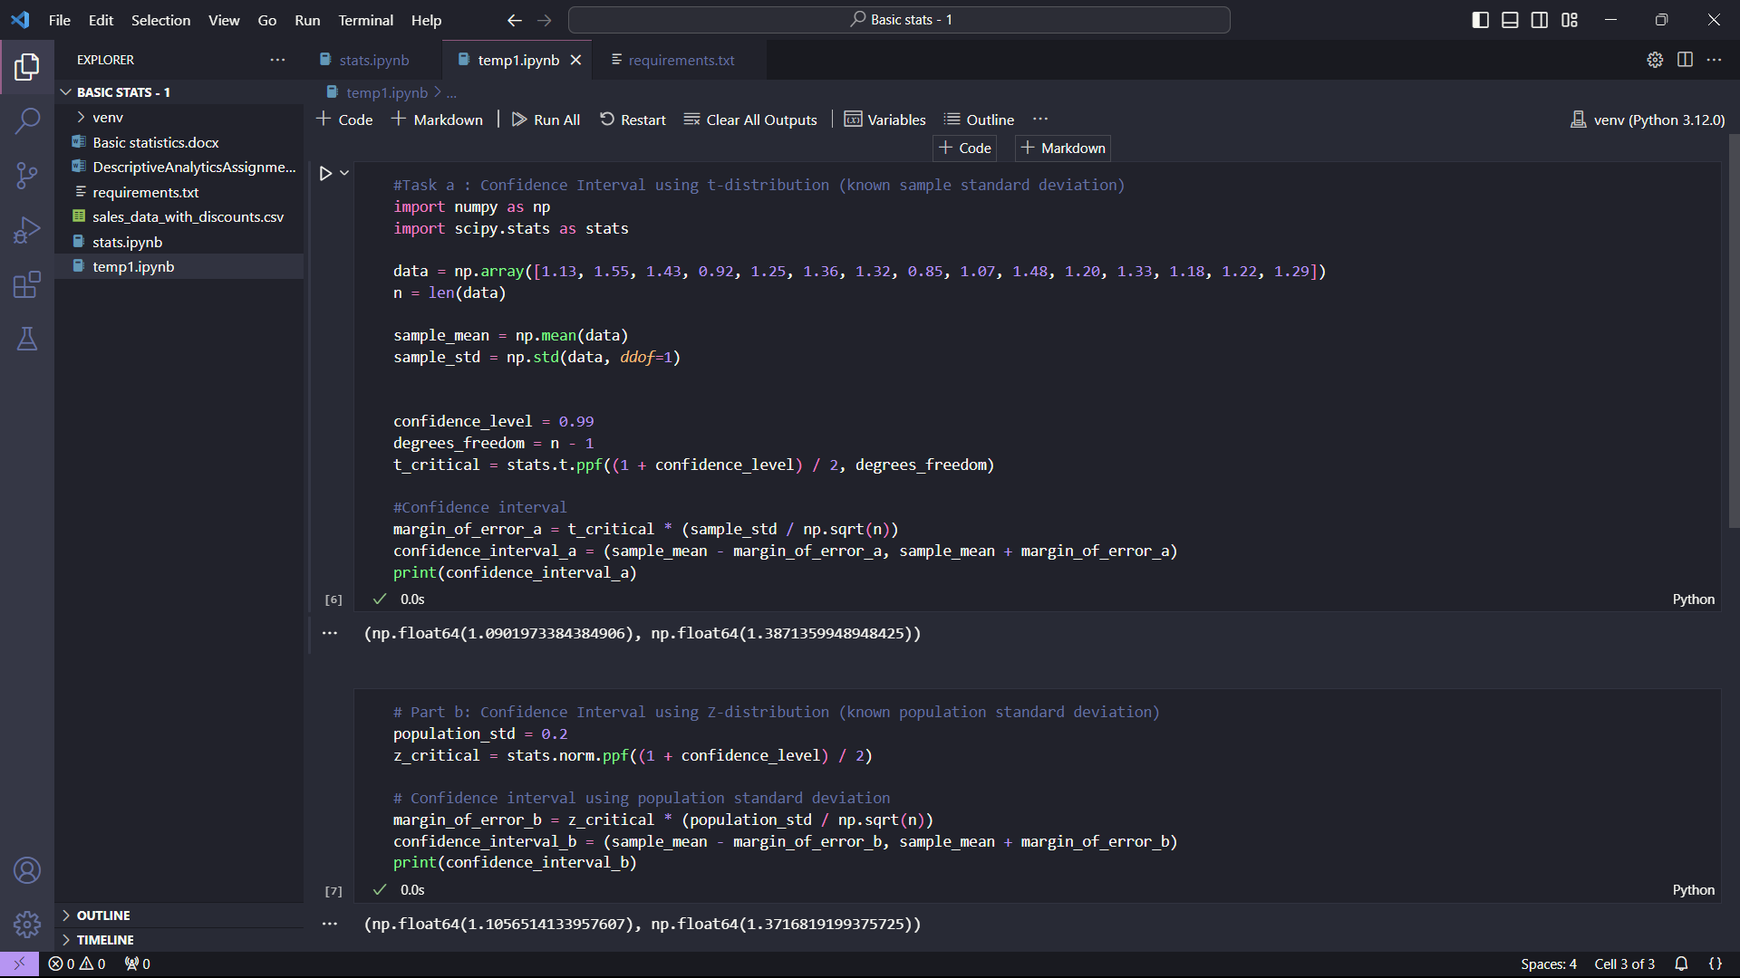

Confidence Interval using t- Distribution **: [1.09,1.387]**

**Task 2:**

99% Confidence Interval Using Known Population Standard Deviation.

If the population standard deviation is known (σ = 0.2 million characters), we can use the normal distribution (Z-distribution) to construct the confidence interval.

**Steps:**

1. **Z-value**: For a 99% confidence level, find the corresponding Z-critical value.
2. **Confidence interval formula**:

$$\overline{x}±Z_{α/2}×\frac{σ}{\sqrt{n}}$$

Where $Z_{α/2}$ is the critical value from the Z-distribution, and σ is the known population standard deviation.

**Code:**



Confidence Interval using z- Distribution **: [1.106,1.372]**